**Test Case** **0005**

**System:** VirtuCardClient & VirtuCardHost

**Description:** Tests that the client can skip their turn successfully

**Severity:** 2

**Instructions**

**Test1**

1. Start VirtuCardClient application
2. Click the button labeled “Sign In”
3. Enter “virtucards01@gmail.com” into the text input labeled “Enter email…”
4. Enter “Testing1” into the text input labeled “Enter password…”
5. Press the button labeled “Login”
6. A window should appear saying “Login Success”
7. Press the OK button that appears on that window
8. Start a second VirtuCardHost application
9. Repeat steps 2-7, but use “virtucards02@gmail.com” as the email and use “Testing1” as the password.
10. Start VirtuCardHost application
11. Repeat steps 2-7 but on the VirtuCardHost application
12. The checkbox “Allow Host to Join” should be checked on the host
13. Select the “Freeplay” option from the game choices dropdown
14. Press the Create Game button
15. In the first VirtuCardClient application enter the 6-character room code found on the host’s screen into the field labeled “Enter Code…”
16. Press the Join Game button after it has loaded
17. Repeat previous two steps except on the second VirtuCardClient application
18. After the names TestCase0001 and TestCase0002 appear in the player list on the host side, press the Start Game button
19. After the clients have loaded into the game screen, the Skip Turn button should be interactable by only one of them.
20. Monitor the host side’s screen and verify that the name of whose turn it is matches with the client that has the skip turn button interactable
21. Press the skip turn button on the client that has it available

**Expected Result:** The other client that did not have its skip button pressed should have its skip turn button interactable now. Additionally, the host should have changed the name of whose turn it is to the current client that has its skip turn button interactable.

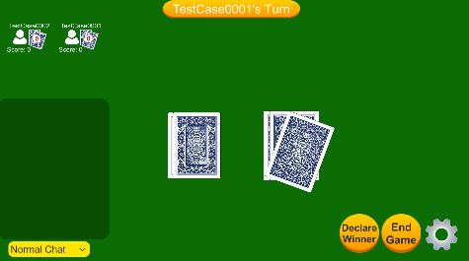**Host Side**

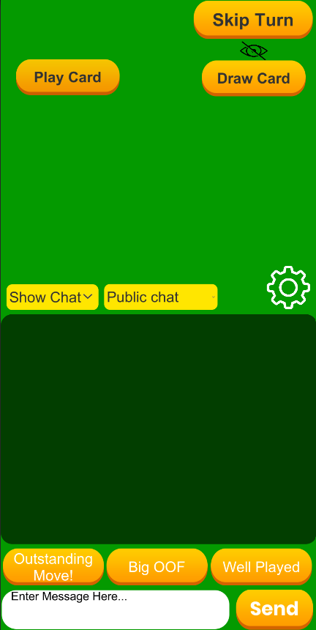**Client 1’s Side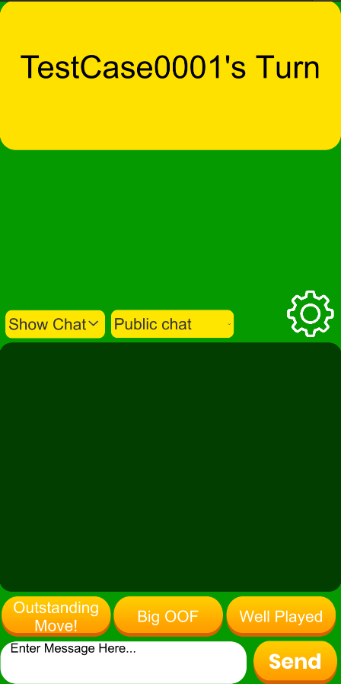 Client 2’s Side**

**Test2**

1. Start VirtuCardClient application
2. Click the button labeled “Sign In”
3. Enter “virtucards01@gmail.com” into the text input labeled “Enter email…”
4. Enter “Testing1” into the text input labeled “Enter password…”
5. Press the button labeled “Login”
6. A window should appear saying “Login Success”
7. Press the OK button that appears on that window
8. Start a second VirtuCardHost application
9. Repeat steps 2-7, but use “virtucards02@gmail.com” as the email and use “Testing1” as the password.
10. Start VirtuCardHost application
11. Repeat steps 2-7 but on the VirtuCardHost application
12. The checkbox “Allow Host to Join” should be checked on the host
13. Select the “Freeplay” option from the game choices dropdown
14. Press the Create Game button
15. In the first VirtuCardClient application enter the 6-character room code found on the host’s screen into the field labeled “Enter Code…”
16. Press the Join Game button after it has loaded
17. Repeat previous two steps except on the second VirtuCardClient application
18. Press the Start Game button on the host application
19. Press the Skip Turn button on the client that has it available
20. Press the Skip Turn button on the client who just received the turn

**Expected Result:** The first client, whose skip button was pressed, should have its skip button interactable again, and the host should display that user’s name. The second client should not have it interactable.

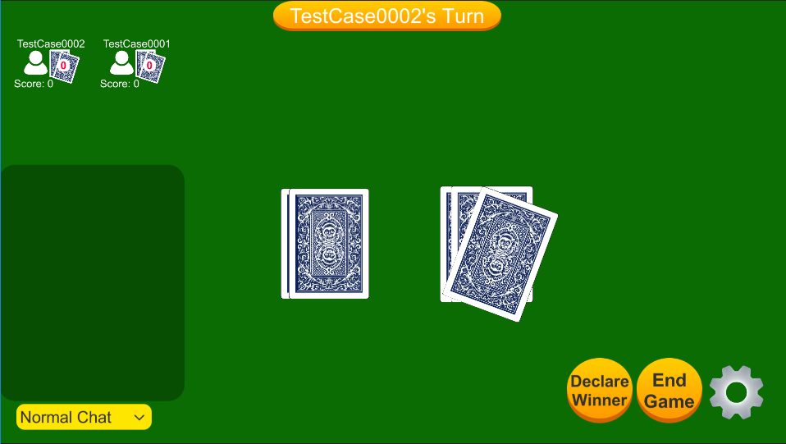**Host Side**

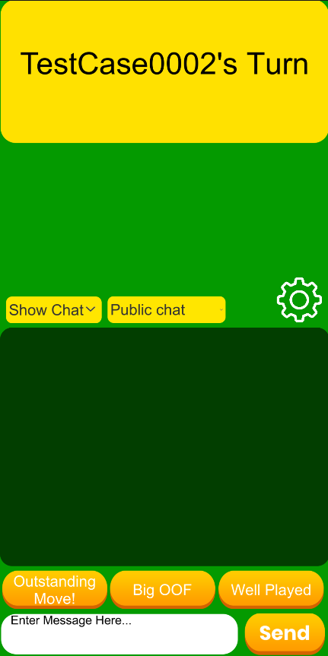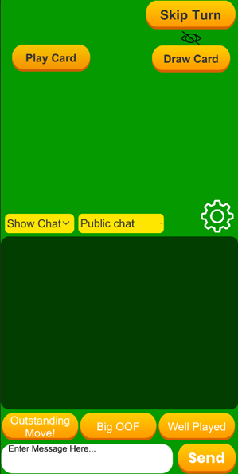**Client 1’s Side Client 2’s Side**

**Test3**

1. Start VirtuCardClient application
2. Click the button labeled “Sign In”
3. Enter “virtucards01@gmail.com” into the text input labeled “Enter email…”
4. Enter “Testing1” into the text input labeled “Enter password…”
5. Press the button labeled “Login”
6. A window should appear saying “Login Success”
7. Press the OK button that appears on that window
8. Start a second VirtuCardHost application
9. Repeat steps 2-7, but use “virtucards02@gmail.com” as the email and use “Testing1” as the password.
10. Start VirtuCardHost application
11. Repeat steps 2-7 but on the VirtuCardHost application
12. The checkbox “Allow Host to Join” should be checked on the host
13. Select the “Freeplay” option from the game choices dropdown
14. Press the Create Game button
15. In the first VirtuCardClient application enter the 6-character room code found on the host’s screen into the field labeled “Enter Code…”
16. Press the Join Game button after it has loaded
17. Repeat previous two steps except on the second VirtuCardClient application
18. Press the Start Game button on the host application
19. Press the Draw Card button on the client that has it available
20. Press the Skip Turn button on that same client

**Expected Result:** The second client, whose skip button was not pressed, should have its skip button interactable, and the host should display that user’s name. The first client should be the only client with a card, and its Skip Button should not be interactable.

**Host Side**

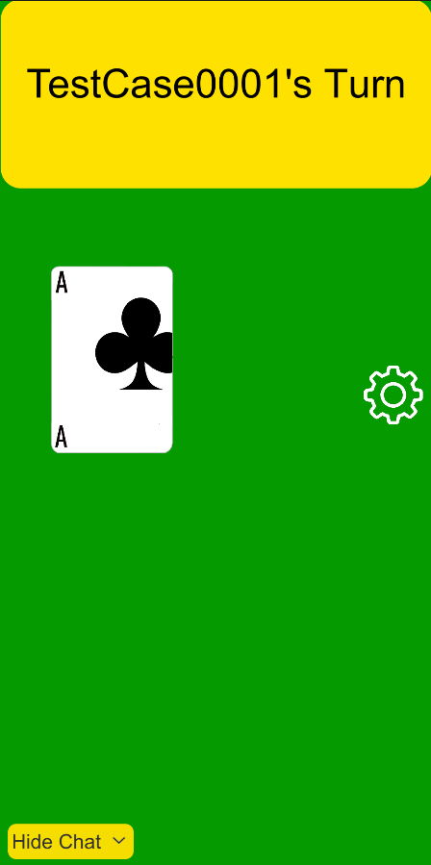**Client 1’s Side Client 2’s Side**

**Test4**

1. Start VirtuCardClient application
2. Click the button labeled “Sign In”
3. Enter “virtucards01@gmail.com” into the text input labeled “Enter email…”
4. Enter “Testing1” into the text input labeled “Enter password…”
5. Press the button labeled “Login”
6. A window should appear saying “Login Success”
7. Press the OK button that appears on that window
8. Start a second VirtuCardHost application
9. Repeat steps 2-7, but use “virtucards02@gmail.com” as the email and use “Testing1” as the password.
10. Start VirtuCardHost application
11. Repeat steps 2-7 but on the VirtuCardHost application
12. The checkbox “Allow Host to Join” should be checked on the host
13. Select the “Freeplay” option from the game choices dropdown
14. Press the Create Game button
15. In the first VirtuCardClient application enter the 6-character room code found on the host’s screen into the field labeled “Enter Code…”
16. Press the Join Game button after it has loaded
17. Repeat previous two steps except on the second VirtuCardClient application
18. Press the Start Game button on the host application
19. Press the Draw Card button on the client that has it available
20. Press the Play Card button on that client after selecting the drawn card
21. Press the Skip Turn button on that client

**Expected Result:** The first client, whose skip button was pressed, should have its skip button non-interactable, and the host should display the other user’s name. The second client should have it interactable. Neither client should have any cards.

**Host Side**

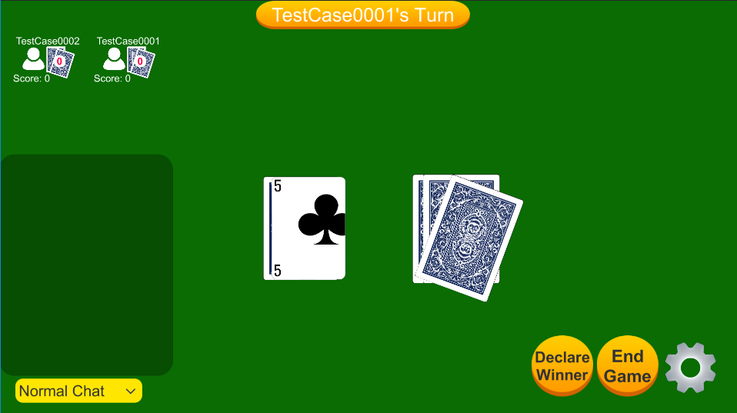

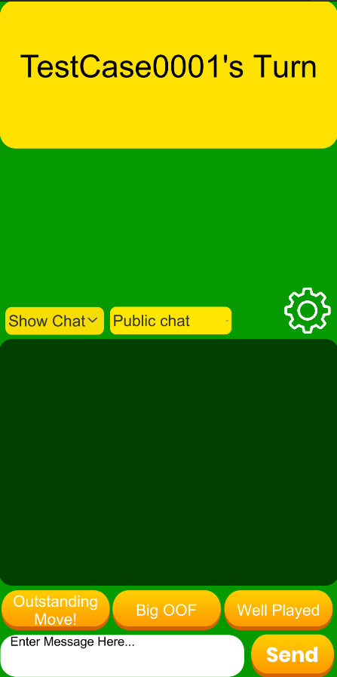**Client 1’s Side Client 2’s Side**